***To:*** Dr. Wu

***From:*** Sam Showalter, Di Shao, David Luo, Nick Ailstock,

***Subject:*** Financial Engineering Project 2

***Date:*** April 9, 2015

**___________________________________________________________________________________**

**Memo:** Beta Hedging and Minimizing Portfolio Risk

**I. Introduction**

Beta hedging—a process by which an investor reduces the overall impact of adverse price movements in his or her portfolio via purchasing assets intended to offset potential losses/gains that may be incurred by a companion investment—is at the center of risk management strategies utilized by firms worldwide. By ensuring that the returns of a portfolio move against the yield of an alternative investment, one can preserve or even build the value of their portfolio over time. To quantify these price movements, securities are compared against an index; it is from this data that beta coefficients are derived.

Colloquially, beta coefficients measure a security’s volatility (also known as systematic risk) in relation to the index it is compared to. The practice of hedging began with Alfred Winslow Jones, a sociologist and journalist who wrote about market behavior in the 1930s and 1940s. In 1949, he founded the first hedge fund and used short selling to hedge his stock portfolio against price drops.

With regard to this project, the portfolio in question will be hedged with futures contracts. Either the S&P 500 E-mini futures or the Russell 2000 E-mini futures will be used to hedge each security in the portfolio. In this case, the securities to be hedged are two large cap stocks (Visa (V), Merck & Co. (MRK)), small-cap stock (Tyler Technologies (TYL)), corporate bonds (LQD), and Treasury bills (TLT). Ultimately, the intentions of this project are to minimize the movement of the value of the portfolio over a three-month period: July 10, 2015 through October 1, 2015. More specifically, while we wish to minimize portfolio movement in general, emphasis is placed on preventing a decrease in portfolio value.

**II. Findings**

Based on the results of this hedging endeavor, preserving portfolio value in the midst of market fluctuations can be optimized with the following practices. With regard to determining beta coefficients, the assets in question must be referenced against an index that mirrors its returns. If this does not occur, it is likely that the returns of the hedging security and the portfolio asset will diverge and lead to fluctuations in portfolio value over time. Especially when an investor intends to shelter his or her portfolio from all market-related risk, any variation in portfolio value is highly undesirable.

In an analogous manner, beta coefficients are often more reliable when analyzed using a rolling window. It is paramount that these coefficients are computed both with a timeframe comparable to that of the hedging period, and in a fashion that reduces anomalous calculations. For example, the covariance between an asset and its index varies, as does the variance of the index overall. By implementing a rolling window into beta calculations, the odds that the timeframe chosen has unique or unexpected prices is greatly reduced. Thus, rolling windows serve to negate the idiosyncrasies of market and asset returns alike.

Lastly, dynamic hedging is a far greater resource for a hedging investor than static hedging. While the initial hedging position an investor takes is not inherently incorrect, market and individual stock returns are dependent (and co-dependent) on a wide variety of exogenous factors not considered by a static position. Subsequently, by re-balancing one’s portfolio as new information arises about the movement of equity and risk-free assets, one can compensate for the latent variables that drive market movement, including human behavior, natural disasters, macro-economic infrastructure, and so on.

**III. Discussion**

***III. a. Methods***

**Understand Static and Dynamic Beta Hedging:** As stated previously, hedging enables an investor to protect his or her portfolio from market trends by purchasing assets whose returns are inversely correlated with the returns of the portfolio itself. The yields of both of these securities are referenced against the gains or losses of a market benchmark to quantify their movement; this reference is represented by the variable beta (β). With that said, beta hedging can take different forms.

Static hedging occurs when all assets are purchased on the initial date, and then remain untouched for the duration of the hedging period. Using the beta coefficient—in a process that will be outlined shortly—the number of short future contracts necessary to shelter a portfolio’s value from market movement can be specified. After these futures are acquired, no further purchases or sales of future contracts will occur in the hedging period.

Conversely—while dynamic hedging utilizes the same process as static hedging to specify the amount of short futures contracts to initially obtained—the amount of futures contracts held by an investor can be adjusted (at the investors discretion) during the hedging period to better protect the portfolio from market movement. Naturally, the ability to adjust one’s hedging position is much more likely to lead to a better preservation of portfolio value. Today, hedge fund investors unanimously utilize dynamic hedging.

As a final note, according to hedging specialists associated with *ETF Analytics,* the frequency of re-balancing is crucial to a successful portfolio. According to their findings, for short term hedging (less than six months), it is more beneficial to hedge as frequently as possible. Especially when the market benchmarks are questionable in their ability to model portfolio returns, re-balancing often may compensate for the vicissitudes of the market and assist the hedger in reducing systemic risk.

**Choosing a Proper Benchmark:** When determining the proper benchmark to use against different securities, it is important to consider the nature of the companies and benchmarks in question. For example, as noted by Angel Ubide, equity indices perform much more effectively when benchmarking equity (risky) securities as opposed to risk free securities. Moreover, large-cap stocks tend to have less volatility in their returns than their small-cap counterparts.

With this information in mind, the S&P 500 Index will be used as a benchmark for large-cap stocks Visa (V) and Merck & Co. (MRK). The same concepts aforementioned also apply to small-cap stocks as well; therefore, the Russell 2000 (small-cap) Index will be used to benchmark Tyler Technologies (TYL). Indeed, as seen in Figures 1 and 2, the movement of the S&P 500 and Russell 2000 imitate the returns of Visa and Merck and Tyler Technologies, respectively. However, the movement of these benchmarks is less variable, largely due to the diversification of these indices in their respective markets.

Now, with regard to risk free securities, Barry Eichengreen of the IMF recommends utilizing a corporate bond and T-bill index for the corporate bond (LQD) and Treasury bill (TYT) section of the portfolio, respectively. However, the only indices available for this project are the S&P 500 and Russell 2000 (see “*III. C. Limitations*” for more information). Therefore, by calculating beta for these securities using both indices, comparing the values, and considering Figures 1 and 2, one can conclude that the Russell 2000 is the better benchmark for these securities.

**Data Collection and Manipulation:** To accomplish the goal of this project, two sets of data need to be collected. For the first set, the adjusted close values for each stock, index, and future utilized in this project must be collected for the previous ten years (Found in the “*(Q1)*” tabs). The data ends on the date of the initial hedge, or July 10, 2015. Moreover, the multipliers for the two futures contracts—the S&P 500 E-mini futures and the Russell 2000 E-mini futures—were found to be $50 and $100, respectively. Secondly, data regarding the adjusted close of these same assets must be found for the dates between July 10, 2015 and October 1, 2015, or the end of the hedging period. This data will be solely utilized for dynamic hedging, and does not have any bearing on the beta coefficients found in this project.

With this data collected and compiled, beta coefficients were then found for different benchmarks and different periods of time. As seen in “*Beta Matrices (Q3 and Q4)*,” the S&P 500 benchmark is used for 30, 60, and 90-day as well as 24, 36, 60, and 120-month beta calculations with each security. Beta coefficients can be calculated by dividing the covariance of the stock and its benchmark by the variance of the benchmark. At the same time, rolling window betas were determined by determining 30 day and 20 month returns (respectively) and calculating accordingly. As seen in Table 1, the rolling window betas tend to be more reliable then other betas, primarily due to their utilization of average returns over longer spans of time. The highlighted beta coefficients shown in the table are those implemented in the static and dynamic hedging portfolios.

**Constructing a Hedging Portfolio:** The process of constructing a static heading portfolio consists of determining initial portfolio value, exploiting this figure to establish the number of future contracts to be shorted (of each kind). Over the hedging period, the returns(losses) of the portfolio should be counteracted by the losses(returns) of the short futures contracts, but no adjustments in future positions are taken. Since a beta coefficient of one implies a security moves with the benchmark it is referenced against, shorting a future contract (that by definition follows the market) should theoretically negate any gains or losses in a portfolio.

**Creating and Adjusting a Dynamic Hedging Portfolio:** An extension of the static hedging portfolio, the dynamic hedging portfolio (correctly) assumes that an initial hedging position may not preserve portfolio value successfully on its own. In turn, based on the portfolio value during the hedging period, the investor’s futures position may be adjusted to counteract any discrepancies with the initial portfolio value.

Considering this idea and supplemental research on beta hedging, our group decided it would be optimal to adjust our futures position every Friday (as much as possible) in our dynamic hedging portfolio. More information regarding the construction and analysis of our dynamic hedging portfolio can be found in the analysis section. Now, the process of adjusting the futures position consisted of determining the difference in value for each security over a portion of the hedging period (three weeks to a month) less the change in futures value. If this figure differs from zero, futures contracts were purchased long or short to eliminate this discrepancy by the ending of the hedging period (or at least the next period of adjustment).

Moreover, this change was not equivalent to the actual discrepancy witnessed. Professional hedge fund managers re-balance their position using complicated functions that depend on these discrepancies. Thus, in order to add some articulation to our model, each futures change calculation (from re-balancing) is multiplied by a scalar value of four. This is done to ensure that the portfolio adjusts quickly enough to move with changes in the stock market. More information on the mathematical nuances of our dynamic hedging portfolio can be found in *“Dynamic Hedging (Q8)*.*”*

**Beta Trends and Fluctuations:** When observing Figures 3-7, one can see beta calculations for a 365-day period, re-calculated each day using a 30-day rolling window. Figures 3-4 are benchmarked with the S&P 500, and the remaining securities utilize the Russell 2000 (which is a more volatile benchmark than the S&P 500). First and foremost, it is clear that the fluctuations of beta over time are directly correlated with the inherent volatility (and therefore the risk) of the security overall. The corporate bond and Treasury bill securities—which carry very little risk—hardly fluctuate in their beta values. Conversely, the equity securities fluctuate rather wildly over the same time period, ceteris paribus.

***III. b. Analysis***

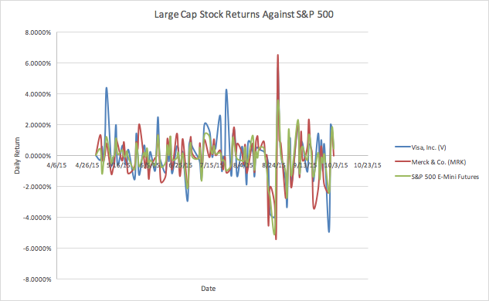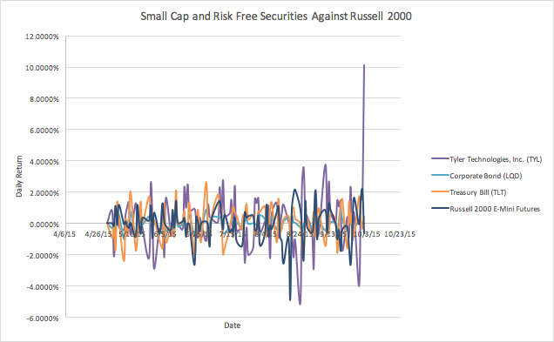

**Figure 1.**

**Figure 2**

**.**

**Beta Plots and Arrays (30 days @ 30 day Rolling Window)**

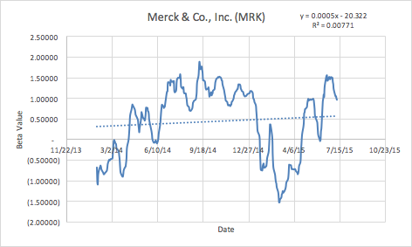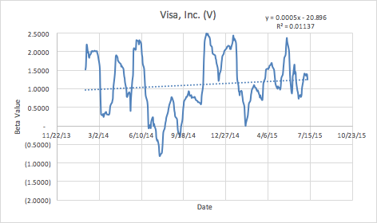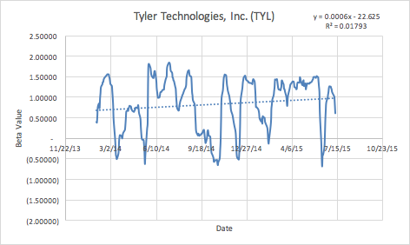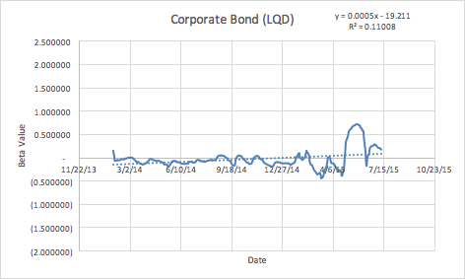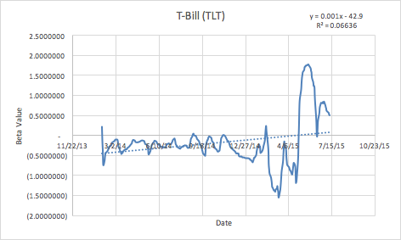

**Figure 3.**

**Figure 4.**

**Figure 5.**

**Figure 6.**

**Figure 7.**

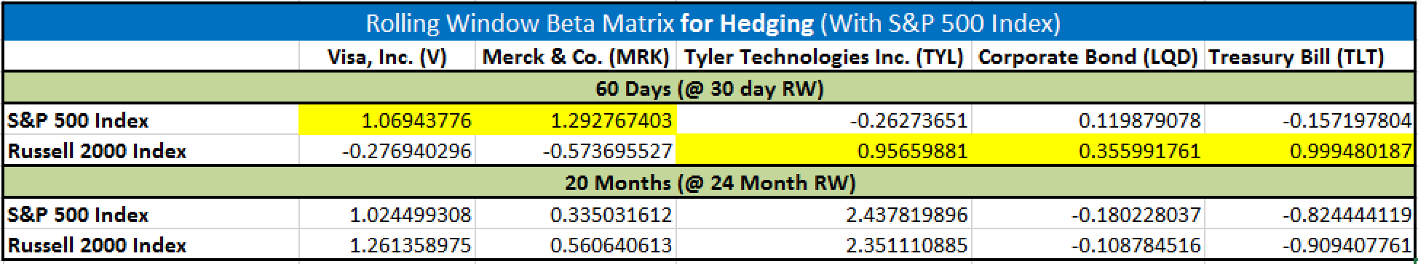

**Table 1.**

**Table 2.**

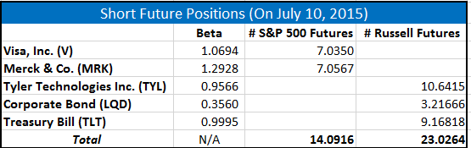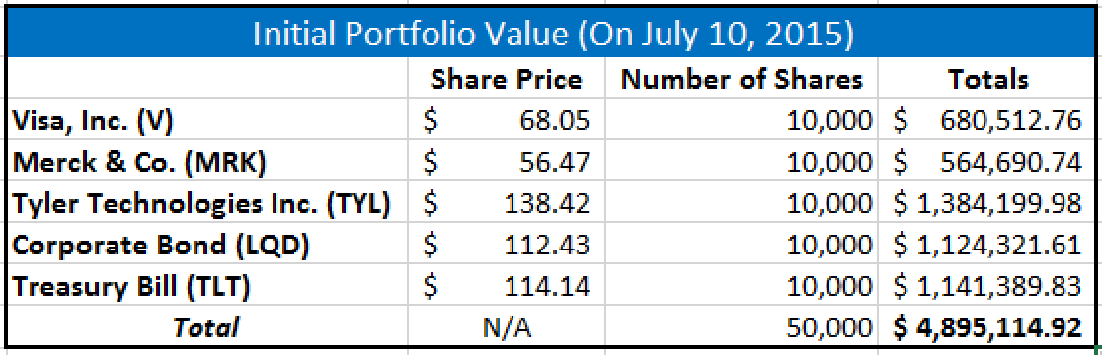

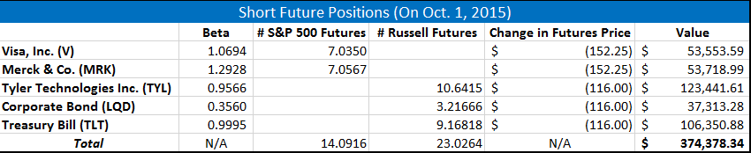

**Table 3.**

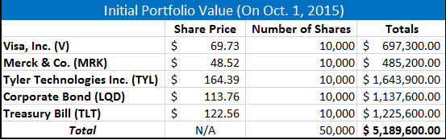



**Table 4.**

**..**

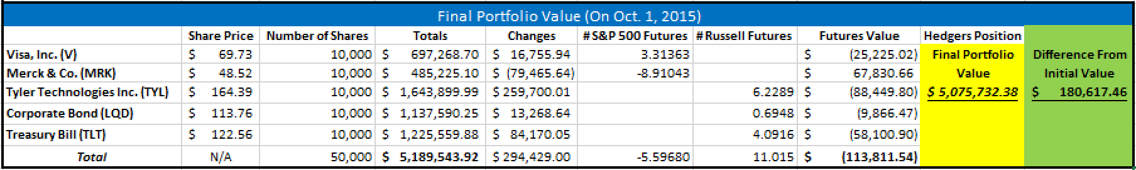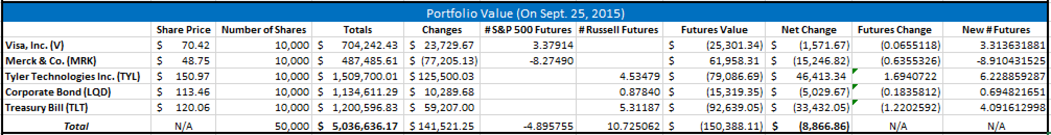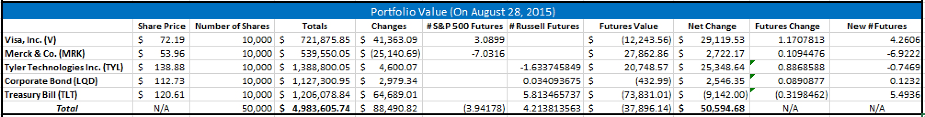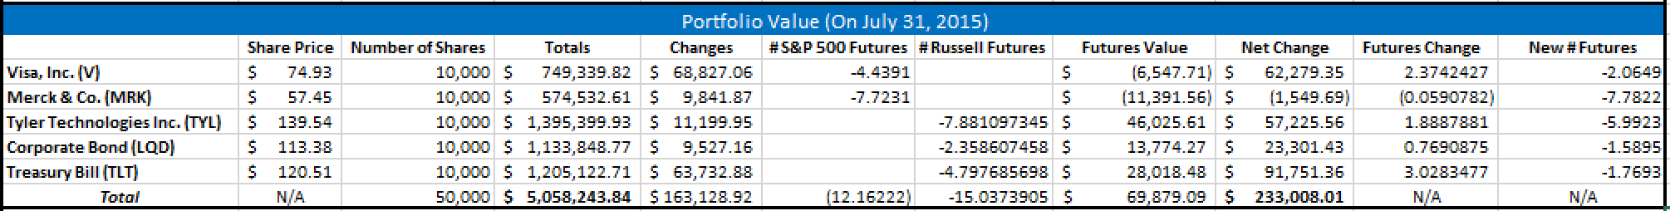

Moreover, what is particularly interesting is the fact that the equity securities (Figures 3-5)—while highly volatile (as represented by R2 values of 0.01137, 0.00771, and 0.018, respectively)—maintain an average beta value of approximately 1. This implies that the indices used to benchmark these stocks are correlated strongly with the returns of the securities. However, as noted in the *Limitations* section, the risk-free indices are not indexed well by equity benchmarks. Thus, Figures 6 and 7 have relatively high R2 values in their beta plots (0.11 and 0.67, respectively), but are not centered on an appropriate beta value (of approximately 1).

**Static Hedging Analysis:** As seen in Tables 2 and 3, the static hedging portfolio was created in three major steps: finding initial portfolio value, determining the futures contracts to be shorted, and finding the hedger’s position at the end of the hedging period. In an effort to refrain from being redundant, the results of each step will be emphasized rather than the process, which can be found in the *Methods* section. By multiplying the number of shares of each security by the asset price on July 10th, the initial portfolio can be found to be $4,895,114.92. By looking at the components of the portfolio and their corresponding betas, the number of S&P 500 and Russell 2000 contracts to be shorted was found to be roughly 14 and 23, respectively.

On October 1st, after the hedging period had passed, the final portfolio value became $5,189,600 and the gain on futures was $374,378,34. Thus, the hedger’s position at the end of the hedging period was $5,563,978.34. While this is certainly a favorable short-term gain for an investor, it does not accomplish the goal of preserving the portfolio value. In turn, theoretically this result could have also occurred in the opposite direction, causing a loss. The reasons for the discrepancy in initial and final value can be attributed to the returns of the stocks in the portfolio and the stock market in general moving in opposite directions (See Figures 1 and 2). This contradiction periodically occurs in the stock market (even with diversified portfolios); altering beta values, by and large, will not compensate for these unexpected diversions between market and portfolio returns. As discussed below, some error can be eliminated with dynamic hedging.

**Dynamic Hedging Analysis:** The process of dynamic hedging is quite similar to that of static hedging, but it allows the hedger to adjust his or her futures position periodically during the hedging period. Our group felt it would be beneficial to adjust the futures position on the last Friday of each week, as stated prior.

At the end of week one, on July 17th, the hedger’s position had increased by $134,110,51. In order to counter this change in value, futures (either S&P 500 or Russell 2000, depending on the asset) were bought long (if net change was positive) or short (if negative) in an amount equal to **four times** the quantity of the *Net Change* (see Table 4). These future changes add to initial futures positions (short futures are denoted shown as negative). This method was repeated each week, though only monthly positions are shown.

At the end of the hedging period, the final portfolio value (excluding the effect of futures) is $5,189,543.92. When including the impact of the futures position on this change, this balance decreases to $5,075,732.38. Clearly, dynamic hedging has been very beneficial to preserving the original value of the portfolio compared to static hedging. With that said, there are still limits to the efficacy of beta hedging. As is noted in the *Limitations* section below, beta hedging cannot account for dramatic swings in stock price. Tyler Technologies, for example, had excellent Q3 earnings in 2015, and their stock price increased over 10% in one day (see Figure 2). Beta hedging has no way to compensate for this, as will be elaborated on shortly. As a result, **if the hedging period had ended ONE WEEK prior, on September 25th, the final hedger’s position would have been *$4,886,435.48*.** This balance differs from the initial portfolio value **by only $8,679.44.** Thus, one can safely assume that the hedging strategy was ultimately successful.

Finally, one can determine the efficacy of this hedging model in an alternative way. As one can see from the raw data spreadsheets, both the S&P 500 and Russell 2000 futures decline in price over the hedging period while the portfolio stock prices increase in value. An occurrence such as this destroys the effectiveness of a static hedging portfolio. However, the dynamic hedging portfolio actually adjusts for this anomaly over time; by the time the hedging period is over, the hedger has purchased long futures contracts to counter the effects of the decreasing futures prices (see Table 4). Such a model is as remarkable as it is versatile.

***III. c. Limitations***

Two main limitations hindered our ability to effectively hedge in this project. To begin, equity indices had to be used as benchmarks for risk-free securities. As a result, the beta coefficients calculated were not as reliable as one created with a risk-free index. That is, if a market that better emulated the returns of the risk-free portion of the portfolio had been utilized, our ability to infer the amount of futures contracts necessary to preserve all risk would have risen substantially.

As previously underscored, the returns of a portfolio in the short-run tend to be more volatile when compared to the long run. If we were to increase our hedging time period we may witness more consistent performance in line with our calculated Beta values. Beta hedging also does not account for unexpected short-term fluctuations, such as the Tyler Technologies Inc., whose stock increased rapidly at the very end of the hedging period, as shown in Figure 2. As stated previously, this dramatic change in Figure 2 impacted portfolio value in an unexpected way that could not have feasibly been hedged against. After more research was conducted, it turns out this increase was due to the release of their quarterly earning statement on October 1st.

**IV. Conclusions**

From the beginning, the intentions of this exploration were to preserve the initial portfolio of several equity and risk free investments through the application of futures contracts. This goal was attempted through multiple avenues, including static and dynamic hedging. As was discovered, beta coefficient calculations—the capstone of beta hedging in general—are volatile and tend to be correlated with the arbitrary returns of an asset. In turn, static hedging—a snapshot attempt to preserve risk over a given period of time—is unable to effectively hedge a portfolio as well as dynamic hedging. In fact, in some instances static hedging can lead to a worse final portfolio value than if hedging had not been utilized at all.

Therefore, by incorporating rolling window techniques into our beta coefficient calculations, we were able to negate much of the variation in the beta values and hedge our portfolio more effectively. At the same time, dynamic hedging enabled us to automatically manipulate our futures position to account for unexpected price changes. The dynamic hedging model chosen in this project was so powerful that it was able to recognize that the price movements of the portfolio and the futures was moving in opposite directions, and was able to shift the futures position so that hedging was still effectual.

Thus, when sheltering a portfolio from market fluctuations, there are a few major facets of hedging that can bolster the hedger’s ability to preserve risk. First and foremost, each asset in the portfolio must be benchmarked by an index that is highly correlated with the returns of the stock in question. As the same time, rolling window calculations tend to remove situational or time-based bias from beta coefficient calculations. Lastly, dynamic hedging should be utilized in a portfolio, and re-balancing should occur consistently. If these guidelines are followed, risk preservation will be optimized and portfolio value will likely be maintained.

**V. References**

Capiński, Marek, and Tomasz Zastawniak. *Mathematics for Finance: An Introduction to Financial Engineering*. London: Springer, 2003. Print.

Eichengreen, Barry. *Hedge Funds and Financial Market Dynamics*. IMF Occasional Paper **41**(166). 22 June, 2012.

ETF.com Staff. "Hedging With Inverse ETFs." *ETF Analytics*. ETF.com. 19 Oct. 2010.

Ubide, Angel, "Finance and Development." *Back to Basics*.The IMF Quarterly **43**(2). 3 Sept. 2013.